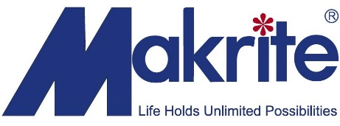

Dear Valued Customer,

As we are sure you know, global demand for face masks continues to skyrocket as China and dozens of other countries around the world are battling the coronavirus.

This increasing demand has given illegitimate manufacturers an opportunity to wedge into the market to produce and sell counterfeit face masks. As a result, we are seeing an increase in the number of cases of manufacturers counterfeiting our products. Moreover, illegitimate companies are also forging fake documents claiming they represent Makrite in China.

Please see the attached document with examples of forged documents and counterfeit Makrite products.

On behalf of Makrite, I would like to officially announce that we have not appointed any distributors in China as representatives for Makrite. If for any reason you have received calls or emails from companies that claim to be our representative, and that they could deliver an on-going supply of face masks from their warehouse, please contact us directly.

We are also seeing unauthorized companies shipping our products without proper packaging. NIOSH requires the user instructions, warning labels, and NIOSH approval labels to be printed on the packaging to ensure users are well informed on specific details of the products. Please note that we have not shipped any masks without proper packaging.

Companies in China are also re-packing our non-filtration dust masks, claiming these masks are N99 grade. This is a violation and considered false advertising or “scamming”.

There has been a surge in fraud and scammers seeking to capitalize during this pandemic. Unfortunately, we have received various calls from people claiming they have been scammed. We have taken legal actions against these companies for their deceptive practices. Please contact us directly if you happen to come across these companies or any suspect behavior.

We are also seeing many companies forging our artwork. If you are unable to identify the authenticity of the Makrite products that you purchased , please contact our Taipei head office on + 886-2-2698-2419 for assistance.

Thank you for your support and understanding.

Bob Wen
CEO of Makrite Industries Inc.

